**Q1. Verify that Eigen value is 4 and Eigen Vector v = (1, 1) for given matrix A.**

**A = $\left[\begin{matrix}1 & 3 \\ 2 & 2\end{matrix}\right]$**

Let’s find the Eigen value of Matrix A.

| A – λI | = 0

$\left|\begin{matrix}1- & 3 \\ 2 & 2-\end{matrix}\right|$ = 0

(1-λ)(2-λ) – 6 = 0

2 – 3λ +λ² -6 = 0

λ²-3λ -4 = 0

(λ – 4)(λ +1) = 0

**λ = 4** or λ =-1

Hence we have verified that **Eigen value = 4**

Let’s find the Eigen vectors of matrix A

(λ I – A) v = 0

For any Eigen value (λ), the Eigen space (Eλ) = N(λ I – A)

For λ = 4, E4 = N(4*I – A)

= N( $4\left[\begin{matrix}1 & 0 \\ 0 & 1\end{matrix}\right]-\left[\begin{matrix}1 & 3 \\ 2 & 2\end{matrix}\right]$ = N($\left[\begin{matrix}3 & -3 \\ -2 & 2\end{matrix}\right]$)

$\left[\begin{matrix}3 & -3 \\ -2 & 2\end{matrix}\right]$ v = O

$\left[\begin{matrix}3 & -3 \\ -1 & 1\end{matrix}\right]$ $\left[\begin{matrix}v1 \\ v2\end{matrix}\right]$ = O

$\left[\begin{matrix}3 & -3 \\ 0 & 0\end{matrix}\right]$ $\left[\begin{matrix}v1 \\ v2\end{matrix}\right]$ = O

$\left[\begin{matrix}1 & -1 \\ 0 & 0\end{matrix}\right]$ $\left[\begin{matrix}v1 \\ v2\end{matrix}\right]$ = O

$v1$– $v2$ = 0

$v1$ = $v2$

**E4 = $\left[\begin{matrix}v1 \\ v2\end{matrix}\right]$ = $\left[\begin{matrix}1 \\ 1\end{matrix}\right]$**

Hence we have verified that **Eigen Vector, v = (1, 1)**

**Q2. Verify that Eigen value is 3 and Eigen Vector v = (2, 1, -1) for given matrix A.**

**A = $\left[\begin{matrix} 1 & -2 & -6 \\ -2 & 2 & -5 \\ 2 & 1 & 8\end{matrix}\right]$**

Let’s find the Eigen value of Matrix A.

| λI – A | = 0

- = 0

$\left|\begin{matrix}-1 & 2 & 6 \\ 2 & -2 & 5 \\ -2 & -1 & -8\end{matrix}\right|$ $\left[\begin{matrix}v1 \\ v2 \\ v3\end{matrix}\right]$ = 0

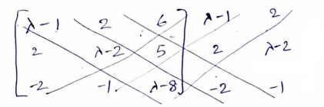

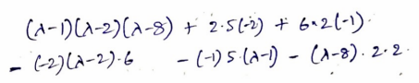

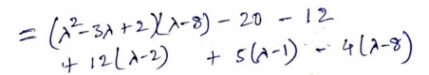

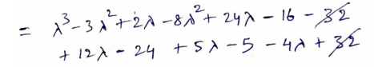

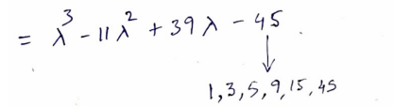

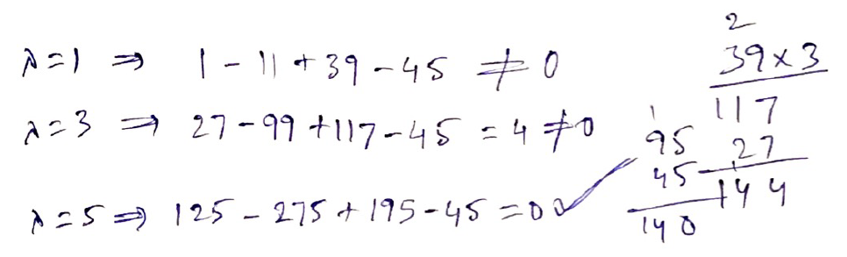

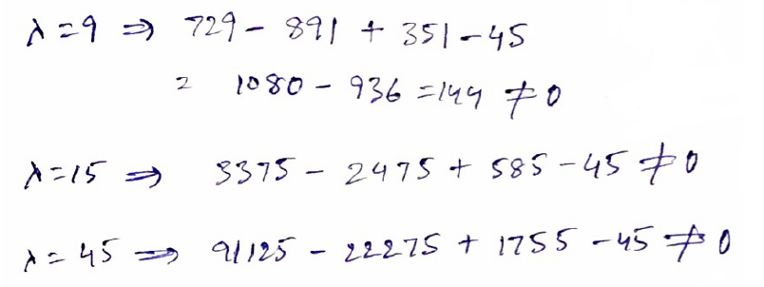

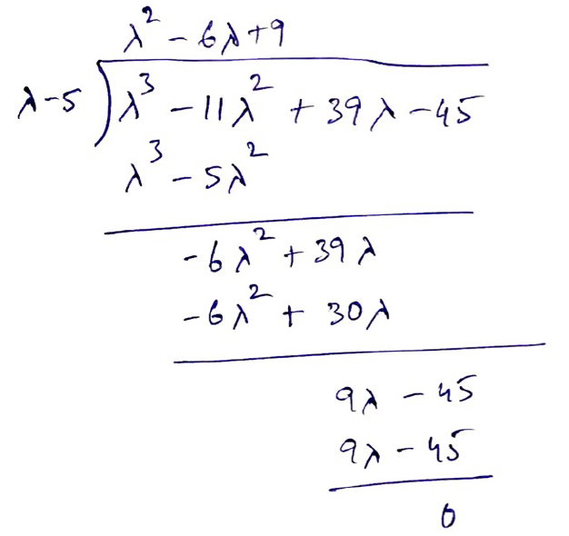

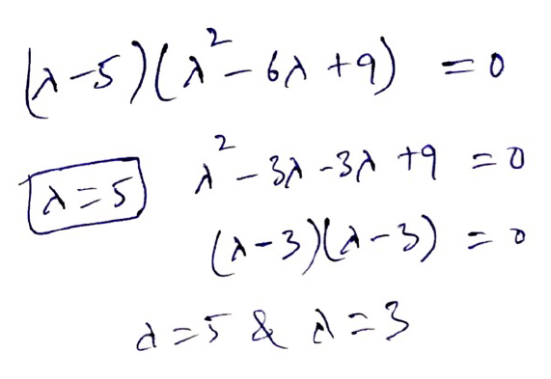

Hence, verified that **Eigen value is 3**

Let’s find the Eigen vectors of matrix A

(λ I – A) v = 0

For λ = 3, E3 = $(3\left[\begin{matrix}1 & 0 & 0 \\ 0 & 1 & 0 \\ 0 & 0 & 1\end{matrix}\right]-\left[\begin{matrix} 1 & -2 & -6 \\ -2 & 2 & -5 \\ 2 & 1 & 8\end{matrix}\right]$)*v* = *v* = 0

* = 0
* = 0

v1+v2+3v3 = 0 -----(1)

v2 + v3 = 0 ---------(2)

Given that, Eigen Vector v = (2, 1, -1)

Substituting the given eigen vector values in above (1) and (2) equations

v1+v2+3v3 = 2 + 1 -3 = 0

v2 + v3 = 1 – 1 = 0

Given Eigen vector values satisfies the equations (1) and (2). Hence proved.

**Q3. Given that v1 = (1, -2) and v2 = (1, 1) are eigen vectors of A, determine the eigen values of A.**

**A = $\left[\begin{matrix}4 & 1 \\ 2 & 3\end{matrix}\right]$**

Let’s find the Eigen value of Matrix A.

(A – λI)v = 0

$\left[\begin{matrix}4- & 1 \\ 2 & 3-\end{matrix}\right]$ v = 0 ----------(1)

Given that v1 = (1, -2) and v2 = (1, 1) are Eigen vectors of A

1. Let’s take v1 = (1, -2)

Substituting the Eigenvector values in (1),

$\left|\begin{matrix}4- & 1 \\ 2 & 3-\end{matrix}\right|\left[\begin{matrix}1 \\ -2\end{matrix}\right]$ = 0

(4-λ)-2=0 🡺 2-λ = 0 🡺 **λ = 2**

1. Let’s take v2 = (1, 1)

Substituting the Eigenvector values in (1),

$\left|\begin{matrix}4- & 1 \\ 2 & 3-\end{matrix}\right|\left[\begin{matrix}1 \\ 1\end{matrix}\right]$ = 0

(4-λ ) + 1 = 0 🡺 5 - λ = 0🡺 **λ = 5**

Eigenvalues of A are **λ = 2** and **λ = 5**

**Q4. Determine all eigen values and corresponding eigen vectors of the given matrix A. If,**

1. **A = $\left[\begin{matrix}1 & 6 \\ 2 & -3\end{matrix}\right]$**

Let’s find the Eigen value of Matrix A.

| A – λI | = 0

$\left|\begin{matrix}1- & 6 \\ 2 & -3-\end{matrix}\right|$ = 0

(1 - λ)(-3 - λ) - 12 = 0

-3 -λ +3 λ + λ2 – 12 = 0

λ2 + 2 λ - 15 = 0

λ2 + 5 λ - 3 λ – 15 = 0

(λ+5)(λ-3) = 0

Hence the Eigenvalues are λ =3 or λ=-5

Let’s find the Eigen vectors of matrix A

(λ I – A) v = 0

$\left[\begin{matrix}-1 & -6 \\ -2 & +3\end{matrix}\right]\left[\begin{matrix}v1 \\ v2\end{matrix}\right]$ = 0 ------(1)

Let’s put the value of λ =3 in the above equation (1)

$\left[\begin{matrix}3-1 & -6 \\ -2 & 3+3\end{matrix}\right]\left[\begin{matrix}v1 \\ v2\end{matrix}\right]$ = 0

$\left[\begin{matrix}2 & -6 \\ -2 & 6\end{matrix}\right]\left[\begin{matrix}v1 \\ v2\end{matrix}\right]$ = 0

2v1 – 6v2 = 0

v1 – 3v2 = 0

v1 = 3v2

Let v2=t, then v1=3t

Eigen Vector for λ=3 is E3 = = =

Let’s put the value of λ =-5 in the above equation (1)

$\left[\begin{matrix}-5-1 & -6 \\ -2 & -5+3\end{matrix}\right]\left[\begin{matrix}v1 \\ v2\end{matrix}\right]$ = 0

$\left[\begin{matrix}-6 & -6 \\ -2 & -2\end{matrix}\right]\left[\begin{matrix}v1 \\ v2\end{matrix}\right]$ = 0

$\left[\begin{matrix}1 & 1 \\ 1 & 1\end{matrix}\right]\left[\begin{matrix}v1 \\ v2\end{matrix}\right]$ = 0

v1 = -v2

Let v1=t, then v2=-t

Eigen Vector for λ=-5 is E-5 = = =

1. **A =**

**Let’s find the Eigen value of Matrix A.**

| λI – A| = 0

$\left|\begin{matrix}-3 & 0 & 0 \\ 0 & -2 & 1 \\ -1 & 1 & -2\end{matrix}\right|$ = 0

(λ - 3)[( λ-2)( λ-2) – 1*1] - 0 + 0 = 0

(λ - 3)[ λ2 - 4λ +3] = 0

(λ - 3)( λ -3)( λ-1) = 0

λ=3 and λ=1

**Let’s find the Eigen vectors of matrix A**

(λ I – A) v = 0

$\left[\begin{matrix}-3 & 0 & 0 \\ 0 & -2 & 1 \\ -1 & 1 & -2\end{matrix}\right]\left[\begin{matrix}v1 \\ v2 \\ v3\end{matrix}\right]$ = 0 ------(1)

1. Let’s put the value of **λ =3** in the above equation (1)

$\left[\begin{matrix}3-3 & 0 & 0 \\ 0 & 3-2 & 1 \\ -1 & 1 & 3-2\end{matrix}\right]\left[\begin{matrix}v1 \\ v2 \\ v3\end{matrix}\right]$ = 0

$\left[\begin{matrix}0 & 0 & 0 \\ 0 & 1 & 1 \\ -1 & 1 & 1\end{matrix}\right]\left[\begin{matrix}v1 \\ v2 \\ v3\end{matrix}\right]$ = 0

0 + 0 + v1 = 0 🡺 v1=0

v2 + v3 = 0 🡺 v2 = -v3

-v1 + v2 + v3 = 0 🡺 v1 = v2 + v3 🡺-v1 –v3 + v3 = 0 🡺 v1=0

Let v2 = t, then v3 = -t

$\left[\begin{matrix}v1 \\ v2 \\ v3\end{matrix}\right]$ = t $\left[\begin{matrix}0 \\ 1 \\ -1\end{matrix}\right]$

We have 2 equations and 3 variables, hence we have infinite number of solutions.

1. Let’s put the value of **λ =1** in the above equation (1)

$\left[\begin{matrix}1-3 & 0 & 0 \\ 0 & 1-2 & 1 \\ -1 & 1 & 1-2\end{matrix}\right]\left[\begin{matrix}v1 \\ v2 \\ v3\end{matrix}\right]$ = 0

$\left[\begin{matrix}-2 & 0 & 0 \\ 0 & -1 & 1 \\ -1 & 1 & -1\end{matrix}\right]\left[\begin{matrix}v1 \\ v2 \\ v3\end{matrix}\right]$ = 0

-2v1 = 0 🡺v1 = 0

-v2+v3 = 0 🡺 v2 = v3

-v1+v2-v3 = 0 🡺 0 +v2 – v2 = 0

Let v2 = t, then v3=t

$\left[\begin{matrix}v1 \\ v2 \\ v3\end{matrix}\right]$ = $t\left[\begin{matrix}0 \\ 1 \\ 1\end{matrix}\right]$

1. **A = $\left[\begin{matrix} 6 & 3 & -4 \\ -5 & -2 & 2 \\ 0 & 0 & -1\end{matrix}\right]$**

**Let’s find the Eigen value of Matrix A.**

| λI – A| = 0

$\left|\begin{matrix}-6 & -3 & 4 \\ 5 & +2 & -2 \\ 0 & 0 & +1\end{matrix}\right|$ = 0

(λ-6)[( λ+2)( λ+1)-0*(-2)] - (-3)[5(λ+1) – 0*(-2)]+ 4 [5*0 – 0(λ+2)] = 0

(λ-6)( λ+2)( λ+1) + 3(5λ+5)+4* 0 = 0

(λ-6)( λ+2)( λ+1) + 3*5(λ+1) = 0

(λ+1) [(λ-6)( λ+2) + 15)] = 0

(λ+1) [λ2 -6λ+2λ-12 + 15] = 0

(λ+1) [λ2 -4λ+ 3] = 0

(λ+1) [λ2 - 3λ - λ+ 3] = 0

(λ+1) [(λ - 3)(λ - 1)] = 0

λ = -1, λ = 1 and λ = 3 are the Eigen values of matrix X

**Let’s find the Eigen vectors of matrix A**

(λ I – A) v = 0

$\left[\begin{matrix}-6 & -3 & 4 \\ 5 & +2 & -2 \\ 0 & 0 & +1\end{matrix}\right]\left[\begin{matrix}v1 \\ v2 \\ v3\end{matrix}\right]$ = 0 ------(1)

1. Let’s find the Eigenvector when λ = -1

Put λ = -1 in equation (1)

$\left[\begin{matrix}-1-6 & -3 & 4 \\ 5 & -1+2 & -2 \\ 0 & 0 & -1+1\end{matrix}\right]\left[\begin{matrix}v1 \\ v2 \\ v3\end{matrix}\right]$ = 0

$\left[\begin{matrix}-7 & -3 & 4 \\ 5 & 1 & -2 \\ 0 & 0 & 0\end{matrix}\right]\left[\begin{matrix}v1 \\ v2 \\ v3\end{matrix}\right]$ = 0

We will get 2 equations with 3 variables, hence we will have infinite number of solutions

R1 🡪 2R2 + R1

= 0

3v1 – v2 = 0 🡺 v2=3v1

5v1+v2-2v3 = 0🡺 5v1 + 3v1 – 2v3 = 0🡺 8v1= 2v3🡺 4v1 = v3

Let v1=t, then

$\left[\begin{matrix}v1 \\ v2 \\ v3\end{matrix}\right]$ = $t\left[\begin{matrix}1 \\ 3 \\ 4\end{matrix}\right]$

1. Let’s find the Eigenvector when λ = 1

Put λ = 1 in equation (1)

$\left[\begin{matrix}1-6 & -3 & 4 \\ 5 & 1+2 & -2 \\ 0 & 0 & 1+1\end{matrix}\right]\left[\begin{matrix}v1 \\ v2 \\ v3\end{matrix}\right]$ = 0

$\left[\begin{matrix}-5 & -3 & 4 \\ 5 & 3 & -2 \\ 0 & 0 & 2\end{matrix}\right]\left[\begin{matrix}v1 \\ v2 \\ v3\end{matrix}\right]$ = 0

(R2) 🡪 R1+R2

$\left[\begin{matrix}-5 & -3 & 4 \\ 0 & 0 & 2 \\ 0 & 0 & 2\end{matrix}\right]\left[\begin{matrix}v1 \\ v2 \\ v3\end{matrix}\right]$ = 0

We will get 2 equations with 3 variables, hence we will have infinite number of solutions

(R3) 🡪 R3-R2

$\left[\begin{matrix}-5 & -3 & 4 \\ 0 & 0 & 2 \\ 0 & 0 & 0\end{matrix}\right]\left[\begin{matrix}v1 \\ v2 \\ v3\end{matrix}\right]$ = 0

-5v1-3v2+v3 = 0

2V3=0 🡺 v3 = 0

-5v1-3v2 = 0🡪 5v1 = -3v2 🡪 v1 = -3/5 v2

Let v2=t, then

$\left[\begin{matrix}v1 \\ v2 \\ v3\end{matrix}\right]$ = t $\left[\begin{matrix}-3/5 \\ 1 \\ 0\end{matrix}\right]$

1. Let’s find the Eigenvector when λ = 3

Put λ = 3 in equation (1)

$\left[\begin{matrix}3-6 & -3 & 4 \\ 5 & 3+2 & -2 \\ 0 & 0 & 3+1\end{matrix}\right]\left[\begin{matrix}v1 \\ v2 \\ v3\end{matrix}\right]$ = 0

$\left[\begin{matrix}-3 & -3 & 4 \\ 5 & 5 & -2 \\ 0 & 0 & 4\end{matrix}\right]\left[\begin{matrix}v1 \\ v2 \\ v3\end{matrix}\right]$ = 0

-3v1 -3v2+4v3 = 0

5v1+5v2-2v3 = 0

4v3 = 0 🡪 v3 = 0

-3v1 -3v2 = 0 🡪 v1 = -v2

5v1 +5v2 = 0 🡪 v1 = -v2

Let v1 = t, then

$\left[\begin{matrix}v1 \\ v2 \\ v3\end{matrix}\right]$ = t $\left[\begin{matrix}1 \\ -1 \\ 0\end{matrix}\right]$